MS Word Office Equation/Formula Tutorial Two

Contents
1. Symbol Shortcuts 2
1.1 Symbol Shortcuts 2
1.2 Shortcut List of First Tutorial 3
2. Edit Equation Using Symbol Shortcuts 3
2.1 Fractions, square roots and exponents 3
2.2 Integral 6
2.3 Matrix 7
2.4 Set Operations 8
2.5 Limit 9
3. Shortcuts for Structures 10
4. Alignment of Equation Array 11
5. Combined with text structures 13
6. Transfer Unicode into Symbol 15
7. Homework Exercise 16

1. Symbol Shortcuts
Were you tired of choosing symbols in the previous tutorial? This time, let’s try a more convenient way to edit equations.

1.1 Symbol Shortcuts
Have you noticed the shortcut codes when you search a symbol from the symbol list?
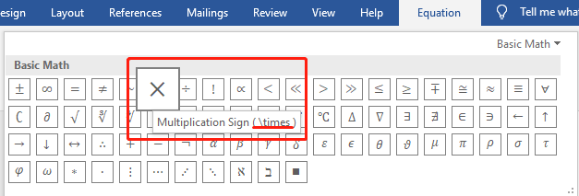
Instead of searching the symbols and clicking the mouse again and again, we can type in the symbol shortcuts in the equation edition area and press “space bar” on the keyboard. Then, MS office will automatically translate the shortcuts into the corresponding symbols.
Below is the shortcut list about the first tutorial, we are going to re-edit the equations in the first tutorial using shortcuts.

1.2 Shortcut List of First Tutorial
Symbol | Shortcut
$$π$$ | \pi
$$σ$$ | \sigma
$$μ$$ | \mu
$$∙$$ | \bullet
$$ε$$ | \varepsilon
$$α$$ | \alpha
$$β$$ | \beta
$$∪$$ | \cup
$$∩$$ | \cap
$$→$$ | \rightarrow
$$∞$$ | \infty
$$≥$$ | \ge

2. Edit Equation Using Symbol Shortcuts

2.1 Fractions, square roots and exponents
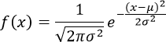
a. Create a new equation
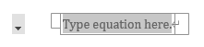
and make sure the equation conversion is Unicode:
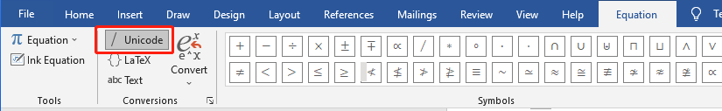
b. Constructure the equation
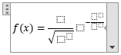
c. Fill in the symbols which can be found in the keyboard
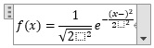
d. Fill in other symbols using shortcuts
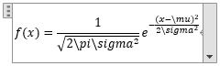
e. To activate the shortcuts, we need to press the ‘space bar’ after every shortcut:
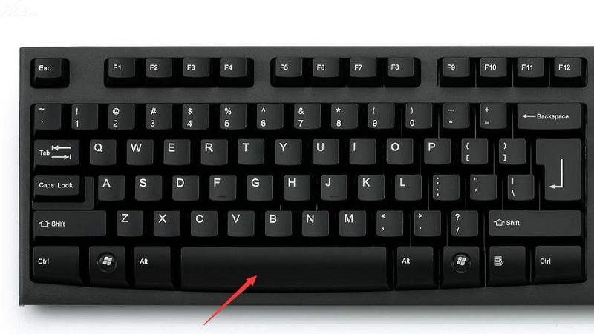
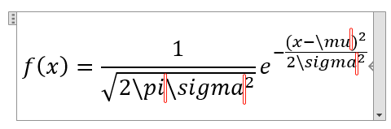
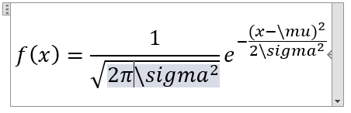
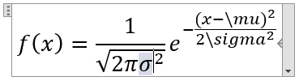
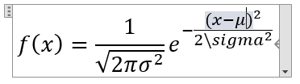
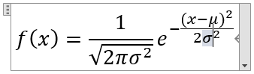

2.2 Integral
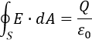
a. Create a new equation
b. Constructure the equation
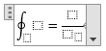
c. Fill in the symbols which can be found in the keyboard
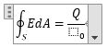
d. Fill in other symbols using shortcuts
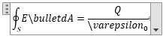
e. Activate the shortcuts
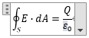

2.3 Matrix
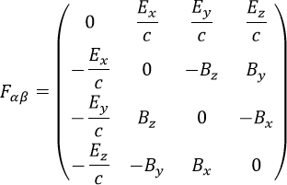
a. Create a new equation
b. Constructure the equation
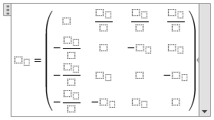
Reminder: You can use ctrl+c and ctrl+v to copy and paste the same structures.
c. Fill in the symbols which can be found in the keyboard
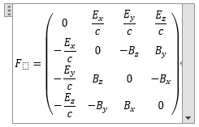
d. Fill in other symbols using shortcuts and activate them.
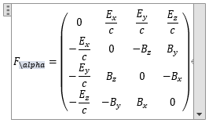
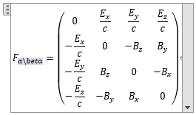
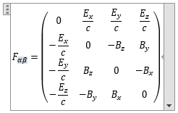

2.4 Set Operations
a. Create a new equation
b. Constructure the equation
c. Fill in the symbols which can be found in the keyboard
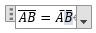
d. Fill in other symbols using shortcuts
e. Activate the shortcuts

2.5 Limit
a. Create a new equation
b. Constructure the equation
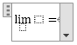
c. Fill in the symbols which can be found in the keyboard
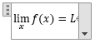
d. Fill in other symbols using shortcuts and activate them
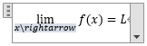
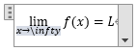
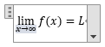

3. Shortcuts for Structures
Besides symbols, structures also have shortcuts. Try the following codes in equations and press “space bar” to see the effect.
- Script
$$a^2$$
$$a_n$$
- Fraction
$$a/b$$
- Parenthesis
$$(())$$
- Summation ( \sum for $∑$ )
$$∑_(i=0)^10$$
- Vector (double space bar)
$$A\backslash vec$$
- Square root ($√$ is given by \sqrt)
$$\sqrt{a}$$
- Matrix
- $■$ is given by \matrix
- Each $\&$ separates two columns
- Each $@$ separates two rows
$$■(\&\&\&@@)$$

4. Alignment of Equation Array
How to edit an equation array with perfect alignment as the following example:
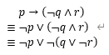
Remember four points:
- Press Alt + $\begin{matrix} + \\ = \end{matrix}$ to create a new equation.
- Put everything in an equation array, that is, activate ‘\eqarray’, then put everything in a pair of parentheses.
- Use ‘&’ for indention
- Use ‘@’ for a new line
Below is the shortcut keys to be used:
Symbol | Shortcut
$$→$$ | \rightarrow
$$≡$$ | \equiv
$$¬$$ | \neg
$$∧$$ | \wedge
$$∨$$ | \vee

Observe the following equation, activate it, and see what happens:
$$█(\&p→(¬q∧r)@≡\&¬p∨(¬q∧r)@≡\&¬p∨¬(q∨¬r))$$

5. Combined with text structures
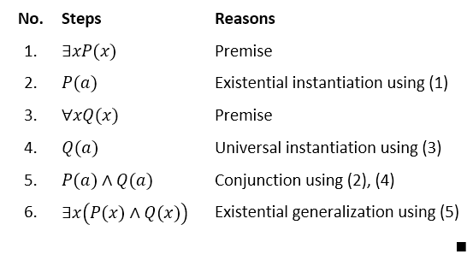
Sometimes only using the equation environment cannot give a perfect structure. Then, text structures can also be combined with equations. For example, a formal proof should be presented as follows.
- Insert a new table of $3×8$
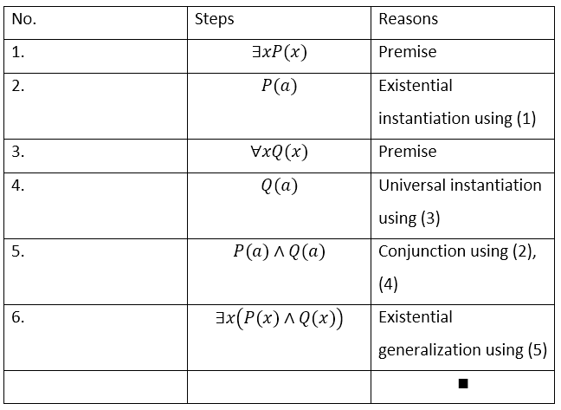
- Type in the content. $∎$ is a Q.E.D box, showing the end of a proof. You can find it from the symbol list.

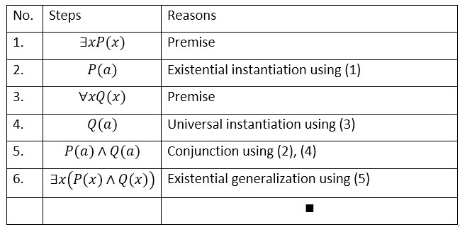
- Adjust the size of rows and columns.

- Align the content. To align equations to the left, one can select the alignment for each equation, or simply insert an empty space after each equation. If text and equations are mixed in one line, MS Office will automatically align them to the left.
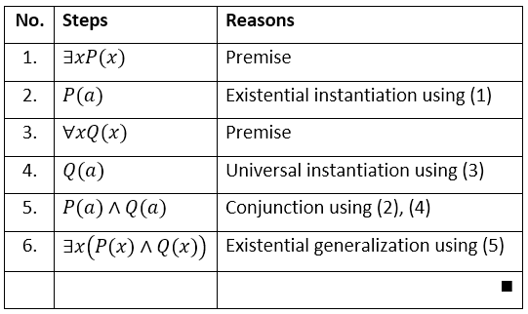
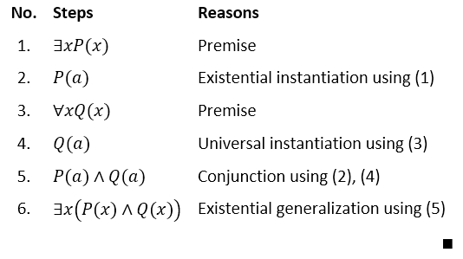
- Select the entire table. Table Design -> Borders -> No Border to hind the borders of the table.

6. Transfer Unicode into Symbol
Sometimes you cannot find a special symbol that you want to insert from the symbol list. And you do not know the shortcut for the symbol. In this situation, you can try to use Unicode. Unicode is symbol dictionary used by computers to represent symbols in 4 hexadecimal numbers. Here is one example.
a. Type 2665 anywhere in the MS document
b. Put the cursor right after ‘2665’
c. Press Alt+X
d. ♥Congratulation! You’ve just finished transferring a Unicode to a symbol.
Unicode can be used in equation. Find the Unicode of normally used math symbol in the following link:
- Mathematical operators

